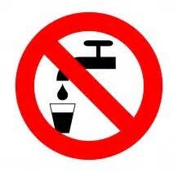
City of Slidell
Boil Water Advisory

NOTICE
DATE: March 24, 2026
Location:
200-226 Normandy Drive
200-208 Mirecourt Drive
104-210 Brittany Lane
105-124 Marche Blvd.
The City of Slidell is advising all users to boil their water as a precautionary measure before using for drinking, cooking, washing food or brushing teeth due to a loss of water pressure in the water system.
The water can be made safe by boiling it for at least one minute at a rolling boil. Boiled water should be stored in a clean container in the refrigerator. Alternatively, bottled water can be used.
You will be notified when water service is returned to normal and the water is safe to drink.
We apologize for any inconvenience.

